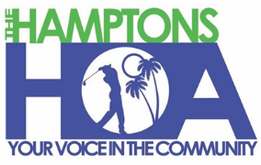
HAMPTON HOMEOWNERS’ ASSOCIATION INC
BOARD MEETING
THURSDAY May 14, 2026

Reminder to silence all cell phones
Pledge of Allegiance
Call to Order
Roll Call of Board Members Present

President’s Report
- A change in voting for Future Hall of Fame selection
Secretary’s Report
- Approval of minutes April 9, 2026 Board Meeting
Treasurer’s Report – Financial Standing

Committee Reports:
Membership- Sharon Guy
Technology and Directory Updates – Marianne Donner-Stone
Recycling and Bingo - Frank Forant
By-laws- Marianne Donner-Stone
Community Concerns – Sharon Guy
Events 2026– Howard Korn
Statutory –

New Business – New Committee Chairpersons

Comments, Questions

Motion to adjourn

