HANDS-ONLY CPR
and
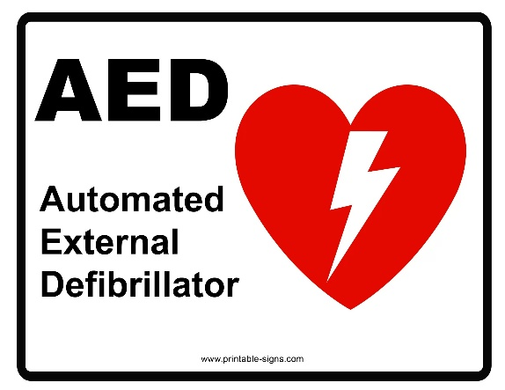
TRAINING
POLK COUNTY PUBLIC EDUCATION OFFICERS WILL BE IN THE
Clubhouse Ballroom on
Monday, March 30, 2026
10 a.m.
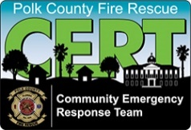
Your Hamptons C.E.R.T. team is proud to share this important information and training with our fellow Hampton Residents

